* Là validation của Hibernate (nhưng độc lập với hibernate core)
* Viết dựa trên Bean Validation của Java
* **Cách sử dụng giống Bean Validation**
* **Setup**

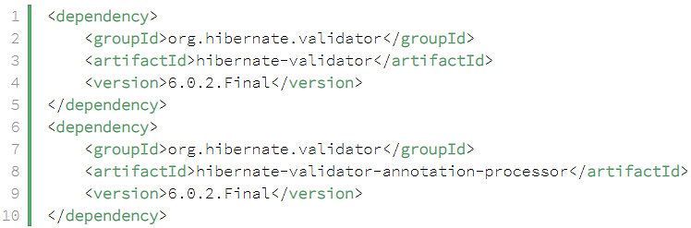

[*https://hibernate.org/validator/documentation/getting-started/*](https://hibernate.org/validator/documentation/getting-started/)

* **Annotation**

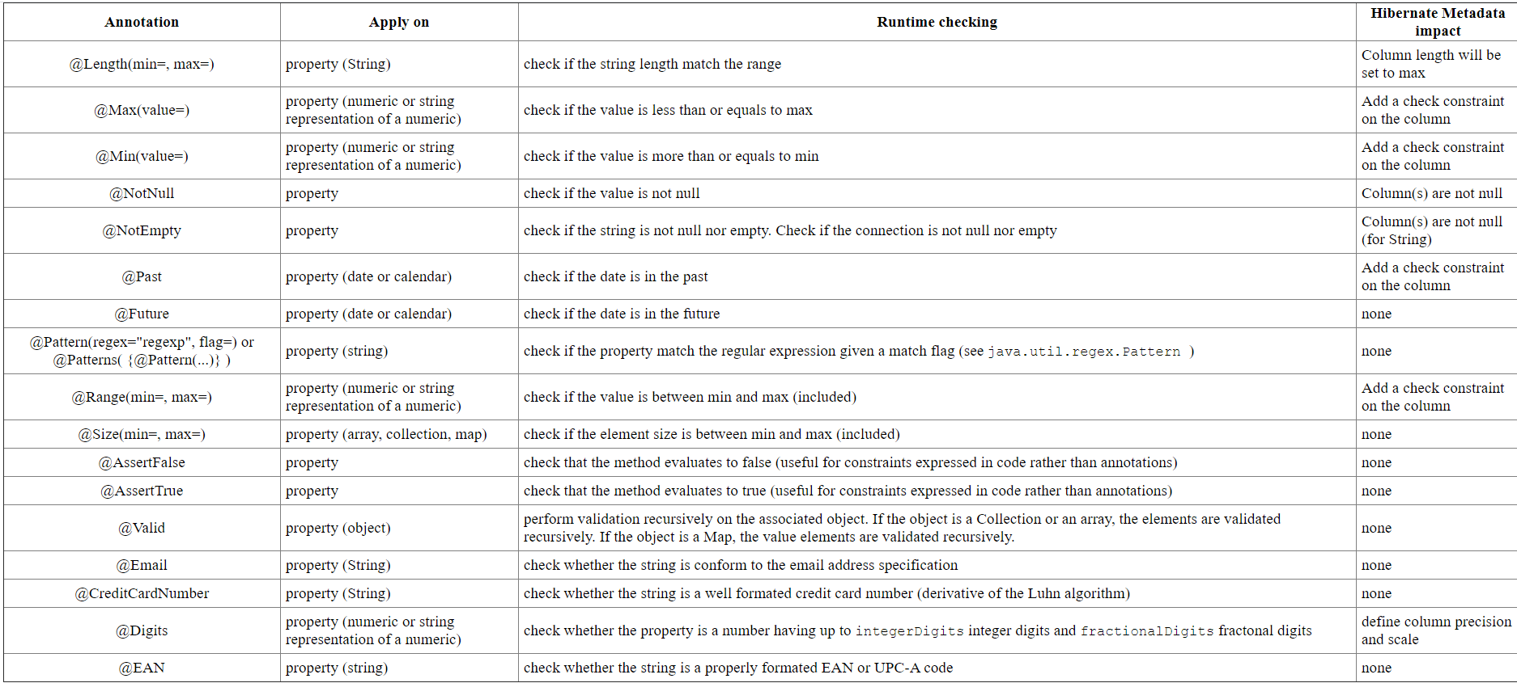[*https://docs.jboss.org/hibernate/validator/3.1/reference/en/html_single/*](https://docs.jboss.org/hibernate/validator/3.1/reference/en/html_single/)

* **Reference**

<https://www.baeldung.com/hibernate-validator-constraints>